1. 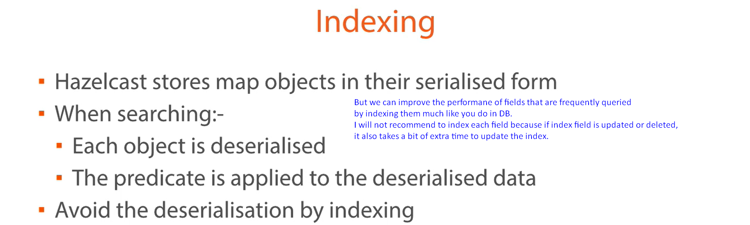  
   So, if you insert, update or delete a lot but don’t query it that often then it is generally not worth it.  
   But on the other hand, if you read from that field a lot then adding an index is probably a good thing to do.
2. **There are two ways of doing this**.
   1. **Way 01**: In the following slide, if we will apply range query then the second parameter must be true.
      1. Text

         Description automatically generated
   2. **Way 02**: Defining index in configuration file (Java Configuration) which is a central approach.
      1. 